**Estonia**

Most of countries official priorities are the reduction of negative environmental of energy use ,the promotion of resource efficiency together with sustainable consumption and production patternsare, reduction in CO2 and other pollutant. Developing their electric mobility Estonia is a good example which trying through electric mobility development achieving its goals . Estonia may not be the first country that comes to mind when you think of electric cars, but the small Eastern European nation was actually the first country in the world to install a [nationwide network of electric vehicle fast chargers](http://cleantechnica.com/2013/02/23/estonia-is-1st-country-in-the-world-to-install-nationwide-system-of-fast-chargers-for-evs/) .By the beginning of 2013, 163 fast chargers have been installed around the country for the comfort of EV users. This report intends to provide a fact-based perspective on the status and current developments of the electrical car charging stations in Estonia.

**Background**

The Kyoto Protocol was ratified by the Estonian Parliament in September 2002. According to the Kyoto Protocol, Estonia had to reduce its greenhouse gases emissions by 8 % in comparison with its 1990 level between 2008 and 2012. Estonia is participating in two Kyoto flexible mechanisms – international emissions trading and joint implementation. In March 2011, the Government of the Republic of Estonia concluded a contract with Mitsubishi Corporation for the sale of AAUs in the amount of 10 million AAUs to start the Estonian electrical mobility programme. The programme consists of three parts: 507 Mitsubishi iMiev electric cars were commissioned by the Ministry of Social Affairs as an example, the Ministry of Economic Affairs and Communications developed a support system for natural and legal persons for acquisition of electric cars, and infrastructure for charging electric cars was created to cover the whole country. Distribution of the purchase grant and the administration of the quick charging network is organised by Foundation KredEx.

**Electrical vehicle in Estonia**

As Demo experience , the Ministry of Social Affairs took 507 Mitsubishi i-MiEV electric cars into use in 2011, That's the largest single order Mitsubishi has ever received for its little car.Estonia electrical vehicle market is very small due to Estonia’s small population which is 1.34 million, but look like most other markets Nissan Leaf is the favorite electrical car for individual buyer in Estonia .

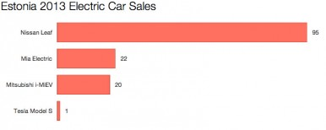

As can be seen , 69% of the market was occupied by Nissan Leaf with 95 sales. Two small vehicles—the Mia Electric and the Mitsubishi i-MiEV—sold 22 and 20 cars, respectively. And there was one Tesla Model S sold in Estonia in 2013.

Estonia has become the second country after Norway in the world in terms of the share of EVs. While there is one electric car registered per each 1,000 cars in Estonia, the respective figure for Norway is four. Estonia is followed by the Netherlands with 0.6 electric cars registered per 1,000 cars.

**Electrical Vehicle Charging infrastructure**

Estonia has become the world’s first country to launch a nationwide fast-charging network for electric vehicles.

The EV fast-charging network is operated by a national foundation KredEx, the chargers were produced and installed by a technology company ABB, the innovative payment solution was designed by NOW Innovations!, and customer support is provided by a security company G4S.

ABB’s fast charging station They conform to the CHAdeMO standard, and each features a 50 kW DC and a 22 kW AC outlet.

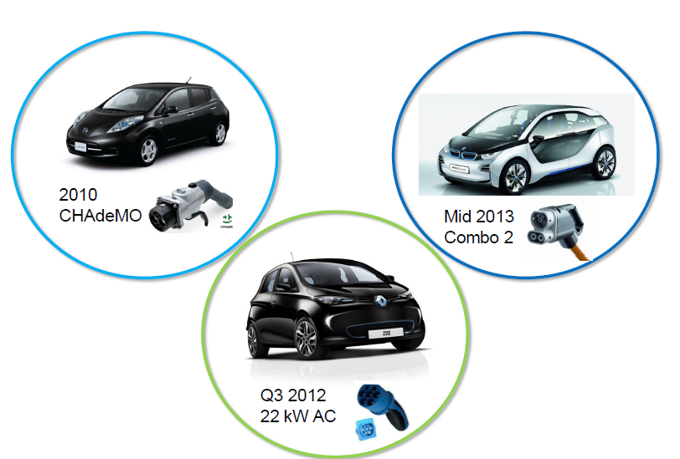

.

The car’s battery can be charged up to 90% in less than 30 minutes and – depending on the model – you will be able to drive for up to 140 km.

Fast-charging points are distributed as follows:

* All roads with dense traffic are covered
* The distance between quick charging points is 40-60 km Suitable and frequently visited places are considered as locations for quick charging stations, e.g. petrol stations, cafes, shops, etc.
* Ports servicing international private transport and local travel ports
* All settlements with over 5000 inhabitants
* In towns, charging points are built in locations where people move anyway – for example, next to shopping centres, petrol stations, post offices, bank buildings, parking lots, etc.

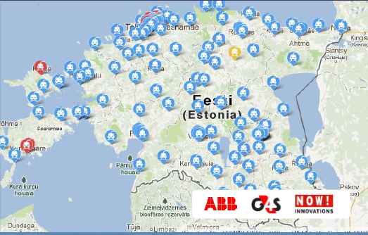

**EV Charging Payment Support**

Fast-charging network users are offered three service packages to choose from:

1- Comined package: user use 1-2 times fast charging service . Monthly fee :10 EURO , pay per charge: 2.5 EURO

2- Flex package: user use 1-2 times fast charging service . Monthly fee :0 EURO , pay per charge: 2.5 EURO

3-Volume Package: user use more than 1-2 times fast charging service . Monthly fee :30 EURO , pay per charge: 1.2 EURO after monthly 150kwh charge is exceeded

Payments can be made using an authorized card (RFID card) or mobile phone. The uniform payment solution can encourage the growth in number of EVs users.

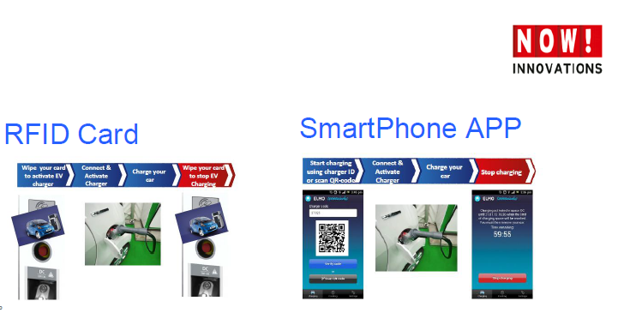

**Improving user EV adoption**

The EV rental project is part of Estonia’s electric mobility program ELMO. The main goal of the rental project is to offer the population the opportunity to drive an EV and thereby reduce consumer uncertainties about adopting a new technology. 18 Nissan Leafs and 6 Mitsubishi iMiEVs are available for rental from outlets in Tallinn and Tartu. These rental points, located in busy public locations such as shopping malls, business centers and central bus/train stations, are equipped with direct current (DC) fast charging points that allow the charging time to be as short as 15-30 minutes.   
the rental just cost 8-10 Euros to rent an EV in Tallinn and user just need to use a Smartphone application or call a number to unlock a car.  
**s Government EV Incentives**

Besides having a public fast-charging network, Estonia promotes a quicker deployment of EVs by providing direct support to both private persons and companies, with the amount reaching up to 18,000 Euros of the all-electric car’s purchasing price. Also, new EV owners can apply for a support of 1,000 Euros for setting up a charging system at their home.

**Challenges**

The main challeng for charging stations is cold winter in Estonia which tempreture can reach lower than -10 degree centigrade which can influence on the operation of the charging stations and charging speed .

